**SQL Constraints, Views , Truncate , delete and update operations**

Week #4

**1. Create tables for the below mentioned Relational design and add check, default, not null and**

**unique constraints**. 10 marks

Ans. Creating a db and creating the tables. Also adding constraints

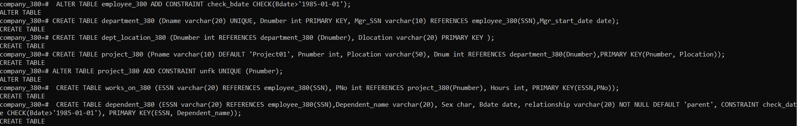

1. Inserting records into the tables

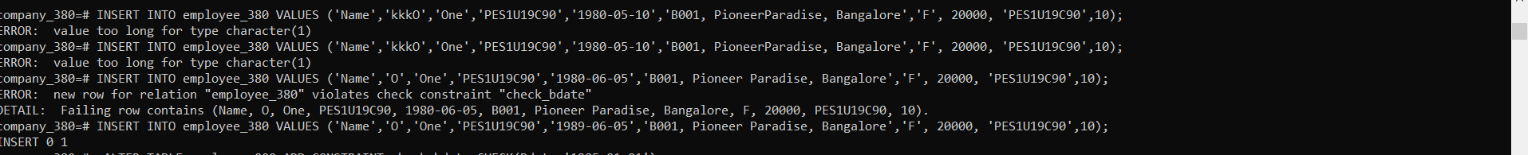

1. creating more tables and Adding constraints



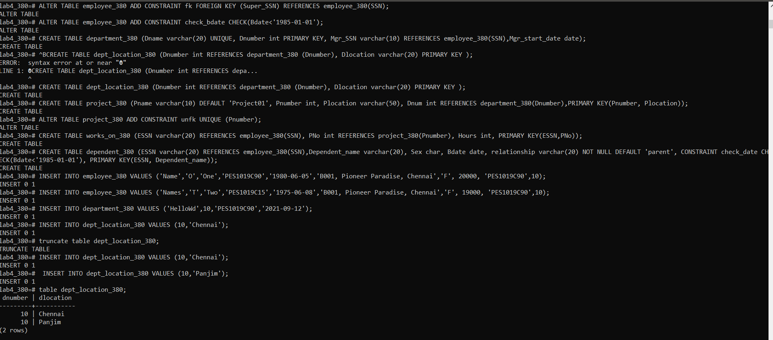

1. Tables in the db:

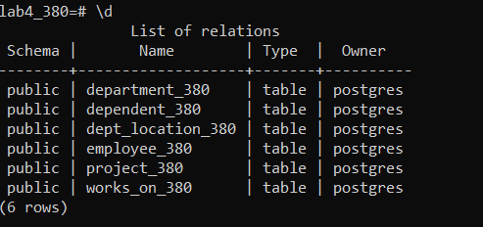

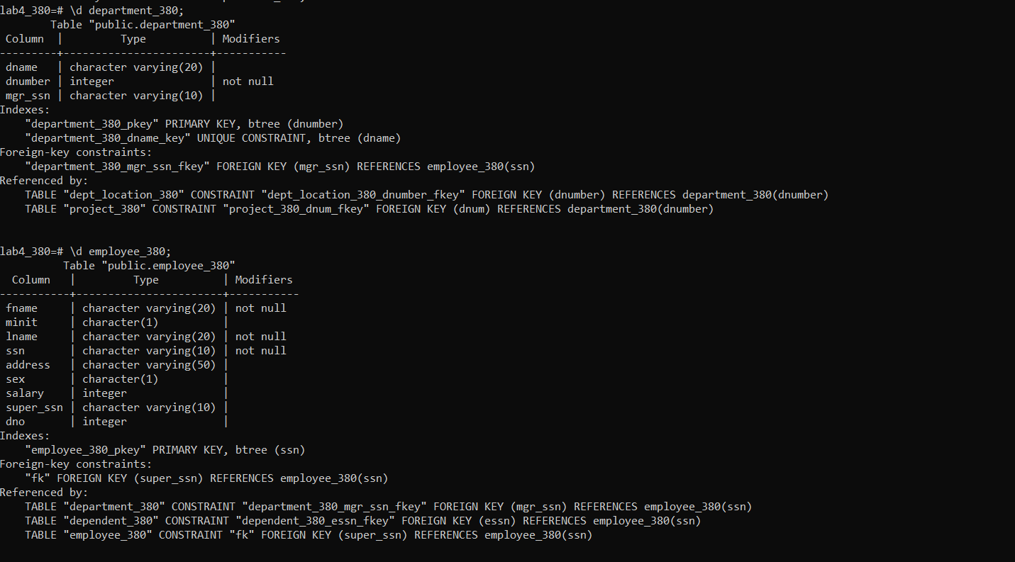

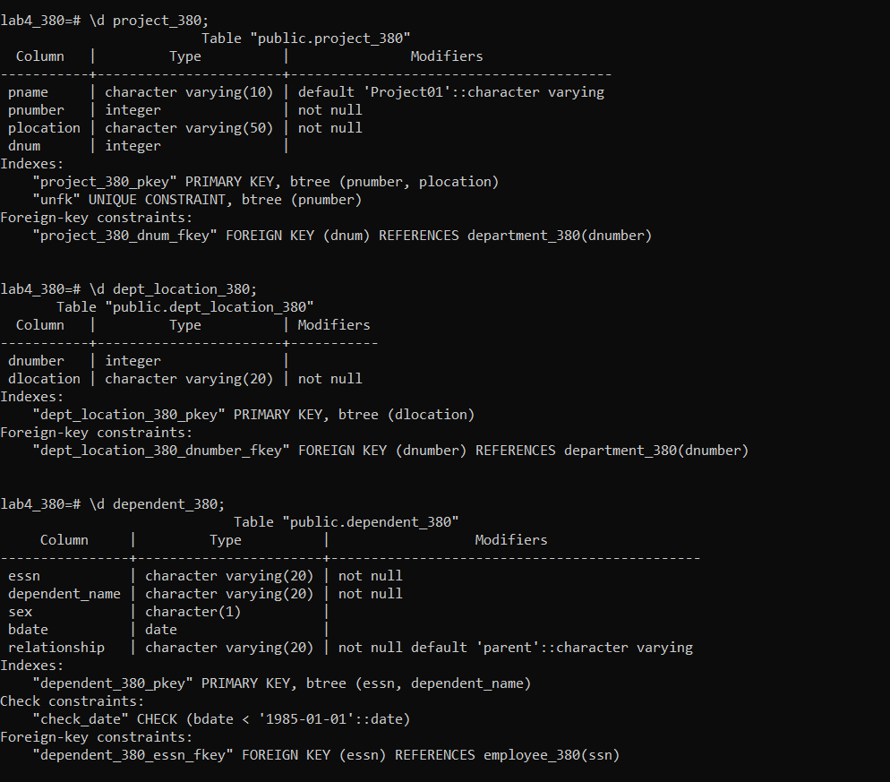

**2. Perform the following operations on the table 4*5 = 20 marks**

* Drop and truncate
* b. Create views and Drop views
* c. Create user and grant and revoke privileges on the table
  + Grant select for emp table for user 1
  + Grant alter privileges on department table for user 2.
  + Grant all privileges on all the table for user 3
* Grant alter ,delete, update on dependent and project table for user4
* Using alter table commands add column , delete column

Ans

1. Drop and truncate

Droping database, table, rows. Truncating table.

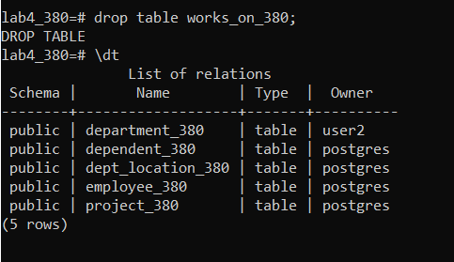

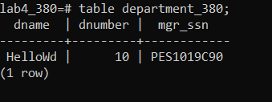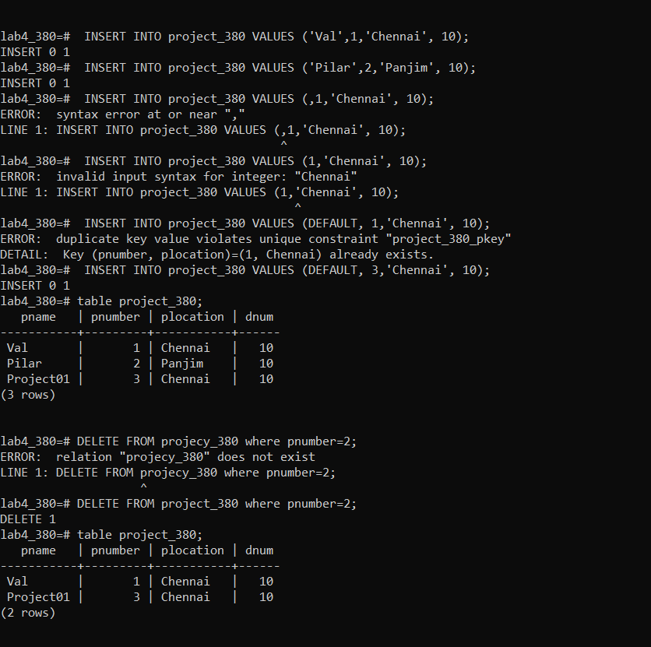

truncate**:**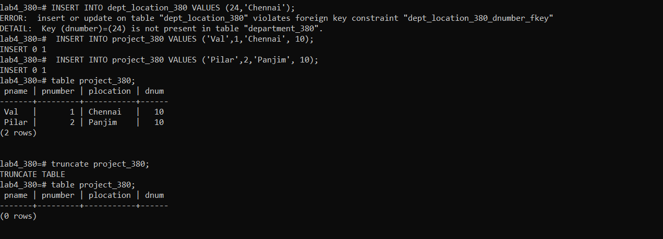

b.)creating and dropping views:

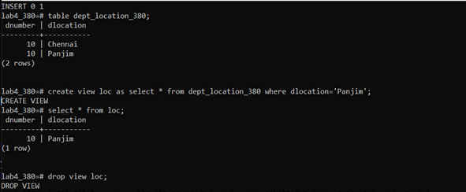

c.)creating roles and granting access:

1.) creating users:

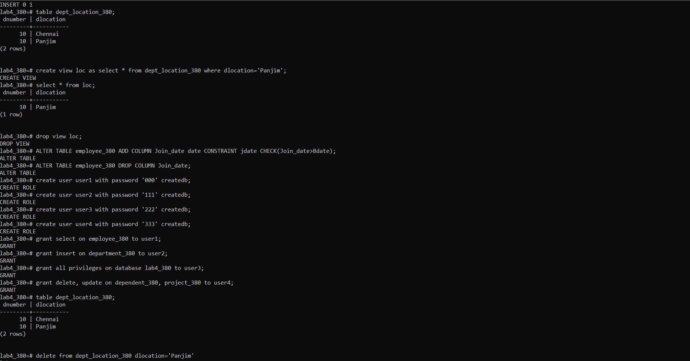

User1:

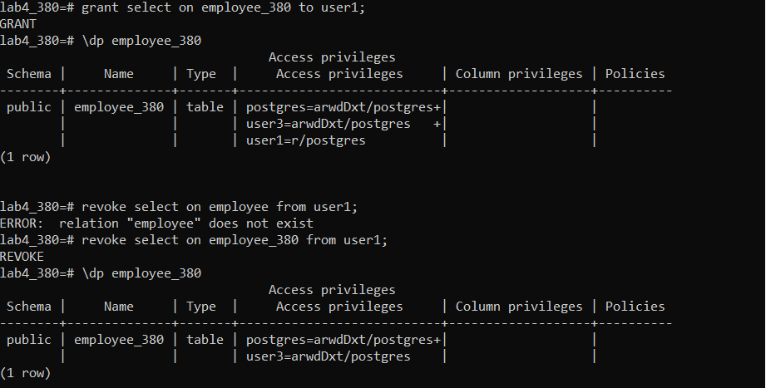

User2:

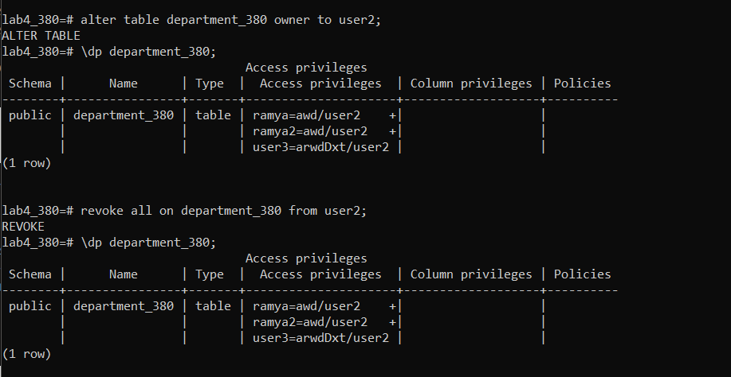

Or

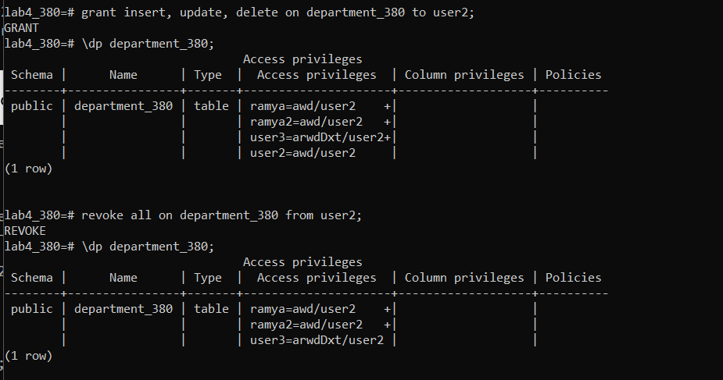

User 3:

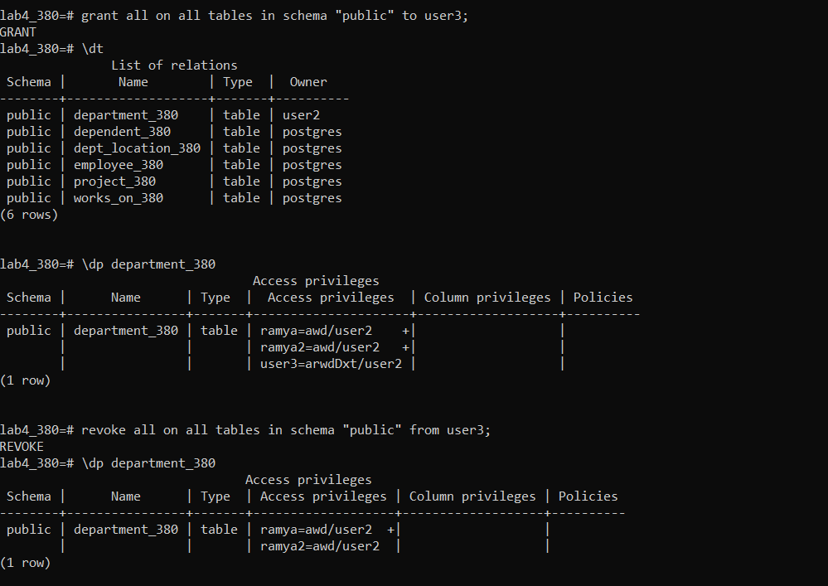

User4:

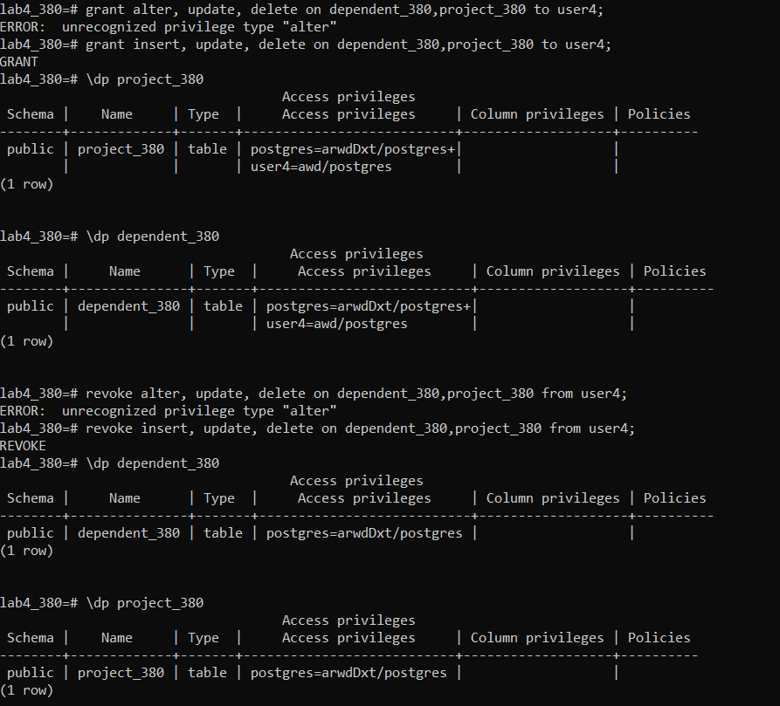

d.) Using alter table commands add column , delete column



